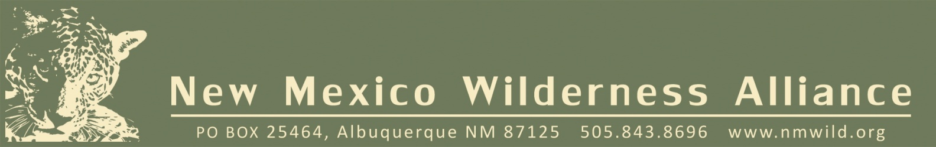

January 25, 2013

The New Mexico Wilderness Alliance (NM Wild) will be holding an online auction in March 2013 as a major fundraising event. Members and other shoppers from across the country will bid online at *http://www.biddingforgood.com/nmwild*.

We are seeking items from donors like you. This is an exciting and worthwhile chance to support the work of NM Wild while promoting your product and brand to a target audience of more than 6,000 people across New Mexico (plus exposure to online bidders across the country). We offer additional free advertising opportunities to donors, which are outlined on the following page.

By supporting NM Wild’s auction you’ll receive:

• Valuable exposure simply for donating an item to our online auction—far beyond that of a traditional in-the-room auction.

• Greater interest in your products/services because we’re sending out numerous e-mail communications and using other powerful promotional vehicles to encourage our members’ participation and support in spreading word about the auction.

The sooner you sign on, the more promotion you’ll enjoy as a generous item donor.

This auction enables us to provide item donors like you with a valuable platform for visibility within our community. The greater the value of the items you choose to donate, the more opportunities for promotion and recognition your organization can receive. We hope you will take advantage of this opportunity and consider supporting our auction.

Thank you and I hope that we can count on your donation to help continue a wilderness legacy in the Land of Enchantment.

Sincerely,

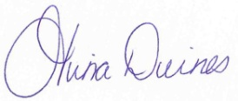

Tina Deines

Communications Coordinator

New Mexico Wilderness Alliance

[*tina@nmwild.org*](mailto:tina@nmwild.org)

505-843-8696, extension 104

Tax ID#85-0457916

|  |  |
| --- | --- |
| **SPONSORSHIP LEVELS** | **BENEFITS** |
| **Jaguar $1000**  jaguar | * Listing in the NM Wild newsletter (45,000 circulation) * Listing in the Wild Guide (150-page guide book sold across the state) * Ad spot on the NM Wild website * Name and logo featured on home page of auction website as a featured partner |
| **Lobo**  4185819  **$500** | * Listing in the NM Wild newsletter (45,000 circulation) * Listing in the Wild Guide (150-page guide book sold across the state) * Ad spot on the NM Wild website * Listing on auction site by name and logo (if provided) |
| **Pronghorn $250**  PRONGHORN | * Listing in the NM Wild newsletter (45,000 circulation) by business name only * Listing in the Wild Guide (150-page guide book sold across the state) by business name only * Listing on auction site by name and logo (if provided) |
| **Roadrunner $100**  roadrunner | * Listing in the NM Wild newsletter (45,000 circulation) by business name only (no logo or ad) * Listing on auction site by name and logo (if provided) |